GIT COMMANDS  
  
  
Git is a version control system tool, while git-hub is a tool used to host the source code of a project in Repositories. The code we deployed in the git will be hosted (stored) in the git-hub in repositories.  
  
  
Repositories are nothing but the project folder or package where we can store our code.

There are two types of repositories   
 1) Local repository: where the current working projects will be stored.  
   
 2) Remote repository: Total projects will be stored here.

After downloading the git we have to open the git bash terminal to do the work, while using this git bash terminal we use commands similar to linux terminal, by using those commands we perform our operations.   
  
Although these commands are similar to Linux commands , they operate different comparing to them .  
  
  
  
  
  
  
git help :  
  
It will display the frequently used git commands in the git bash terminal .  
  
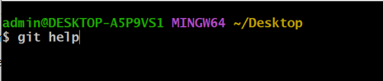  
  
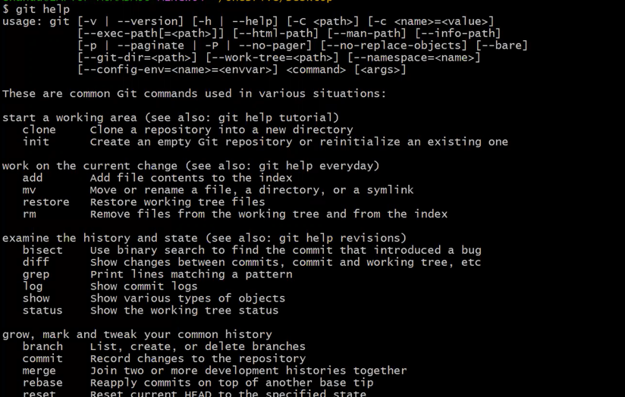  
  
  
  
  
  
  
  
git init:  
  
This command is used to initialize our folder as git working directory.  
  
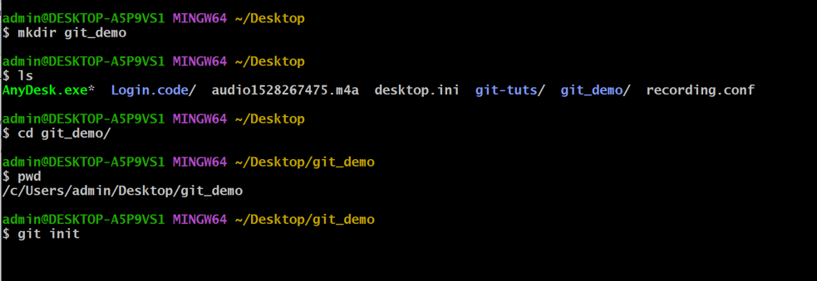  
  
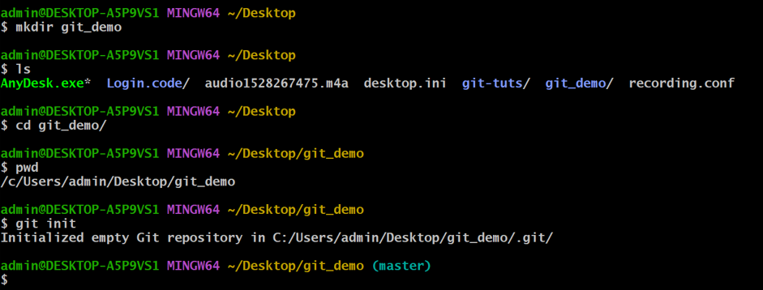  
here git demo folder was initialized as git repository .

User commands :   
  
we have to provide our user details as commands to specify who is performing the current operations .  
  
git config --global user.email “user email here"  
  
  
git config --global user.name "user name here" .  
  
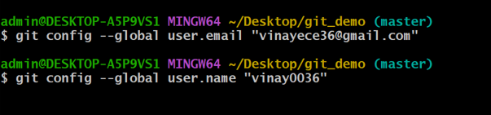

git clone :  
  
To clone the git repositary from the github then we should use git clone command.

git status:  
  
This command will display the staged , un-staged and un-tracked files.  
  
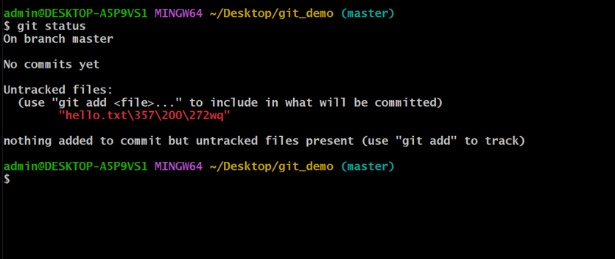  
  
git add:  
  
This command is used to add the files to the staging area .  
  
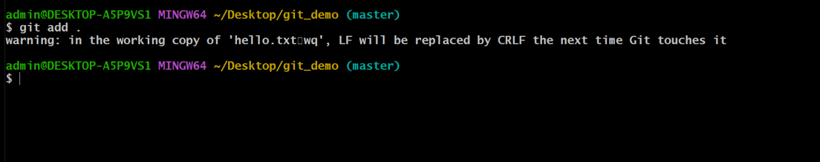  
  
  
  
  
  
  
  
git commit :  
  
This command is used to commit the staged files to the git local repository .  
  
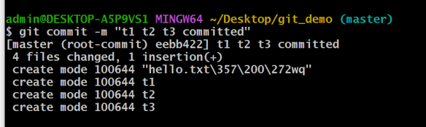  
  
your created files will be committed .   
  
  
git push:  
  
This command is used to push the changes from the local repository to remote repository .  
  
in order to push the code or any particular file we have to give follow these steps ,

git remote add origin paste your link from the git hub repository .

And now ,  
  
  
  
  
  
git push origin master  
  
if we are doing the git push for first time it will ask you to enter the

git-hub password .  
  
your code file will be pushed to the remote repository .   
  
git log :  
  
This command will show all the history of commits in the local repository.  
  
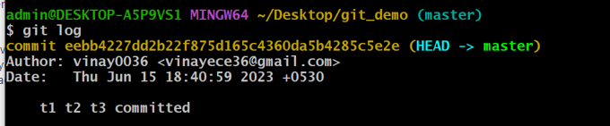  
  
git rm :  
  
git rm command is used to remove the files from different areas.

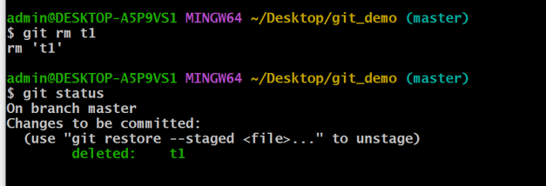  
  
  
  
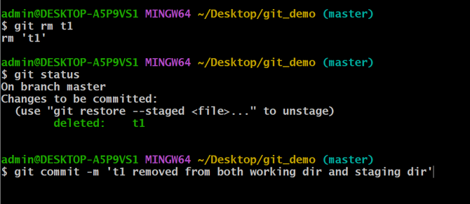  
  
file will be removed from both staging directory and working directory .  
  
git checkout:  
  
we use this git checkout command to discard the un-staged changes in the tracked files of the working directory .